**Hands-On Lab/Demo Script**

**Java Development on Linux with Visual Studio Team Services**

***Exercise 2: Managing your team project backlog***

Lab version: 1.1.0

Last updated: 3/7/2016



In this exercise, you are going to examine the various portfolio planning features of Visual Studio to group and manage your work and that of your team using backlogs. This exercise assumes you have completed Exercise 1, and have created a Team Project using the Scrum template with a Git repo.

This exercise uses a team project named **jdev** (if you have chosen a different name for your project, select the project you created in the previous exercise). For this first part, you will create work items for you in the lab. Later, you will create some more work items as you work through the MyShuttle scenario.

1. Login to your VSTS account and navigate to your project
2. Click the **Work** link.
3. On the left, click the **Features** link.

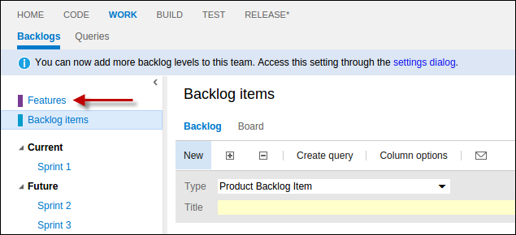

You’re now on the **Features** backlog.

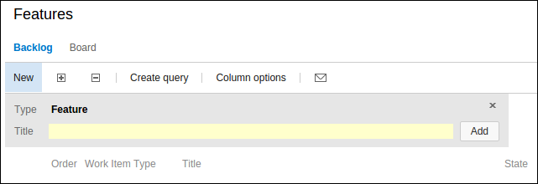

1. In the Title box, enter **Intranet Site Updates** and press Enter.
2. Let’s add another feature. In the Title box, enter **Internet Site Updates** and press Enter.

You now have defined two features.

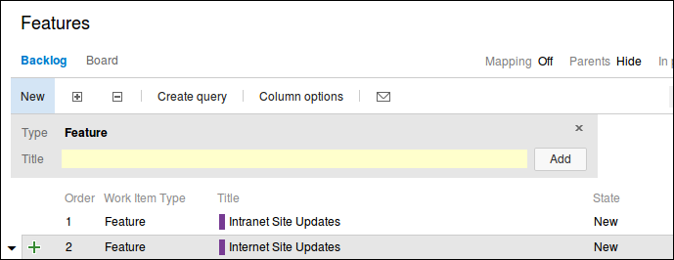

1. Double-click the **Intranet Site Updates** feature to open the feature details and enter additional information such as who owns the feature, status, expected completion date, etc.

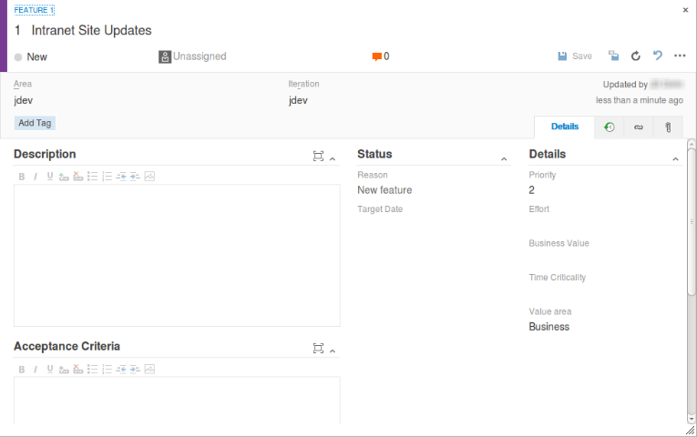

1. Change the value of the **State** field from **New** to **In Progress**.

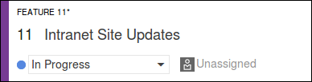

1. Press tab to move to the **Assigned To** field, which current is set to **Unassigned**. Assign it to yourself.
2. Select the **Iteration** field. Expand the combo-box to see the available values.

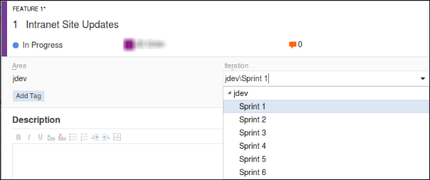

1. Select **Sprint 1**.
2. In the **Description** field, type a short note like, **Complete updates to Intranet site for partners**.

Note this is a rich text field, and you can use various types of formatting.

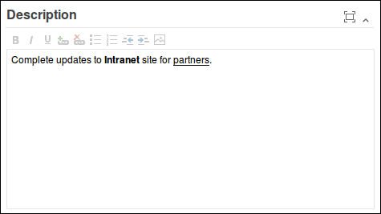

1. Click the links button on the right of the form.



1. Click the **New linked work item** button.

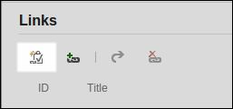

1. Change the **Work item type** field to **Product Backlog Item** and make sure the **Link type** is set to **Child**.
2. In the **Title** field, enter **Site Fit & Finish**.

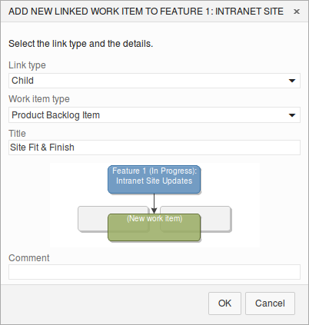

1. Click **OK**. Visual Studio Team Services opens up the New Product Backlog Item screen. Feel free to add a description.
2. When ready click **Save and close**.



1. Back on the Feature dialog, click **Save and close** to update and close the feature.
2. Click the **Backlog Items** link to return to that backlog.

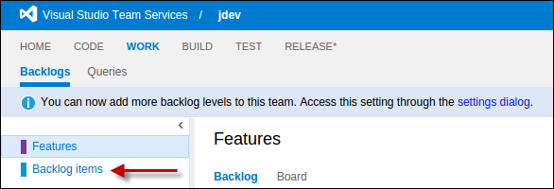

1. Double-click on the **Site Fit & Finish** Product Backlog Item (PBI) in the list to open up the dialog
2. Change the **State** to **Committed**. You’ll notice that it’s assigned to you automatically because the parent feature was assigned to you.
3. Click the links button on the right of the form.



1. Click the **New linked work item** button.



1. Change the **Work item type** field to **Task** and make sure the **Link type** is set to **Child**.
2. In the **Title** field, enter **Add master branding**. Click **OK** when ready.
3. Feel free to explore a bit, add a description if you like and then click **Save and close** to finish using Task dialog.
4. Back at the PBI screen Click **Save and close** to close the Product Backlog Item.
5. Click the small triangle to the left the Explore VS Team Services PBI.

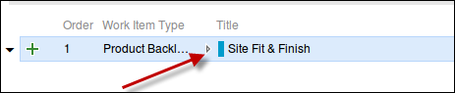

You can now see any of the child tasks associated with the PBI.

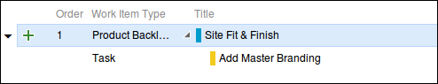

You can also see parent items (in the case Features).

1. On the command bar above the backlog, click the Hide link to the right of the Parents label to “show” the parent Features.



You now can see the Parent Features.

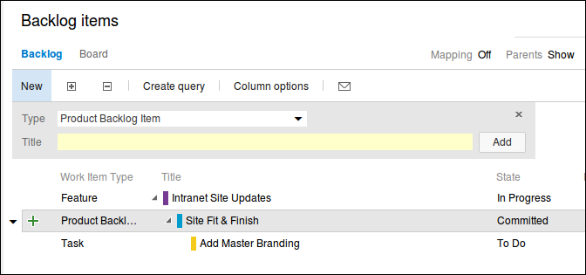

1. Under the Backlog items title, click the Board link.

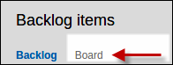

1. In the Committed column, on the only card, click the  item.

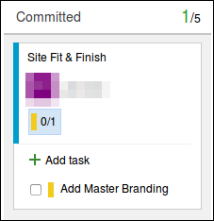

You can see the child task here.

1. Click the **+ Add task** item.
2. In the open text area, type **Add master navigation to menu page** and press **Enter**.

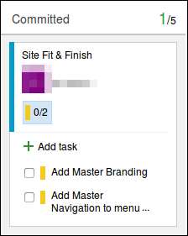

You can see all of your work for the active sprint by accessing the **Task Board**.

1. On the left, click **Sprint 1** under **Current**.

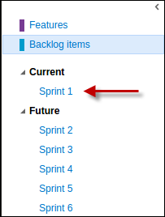

Now you can see your work for the just the current sprint.

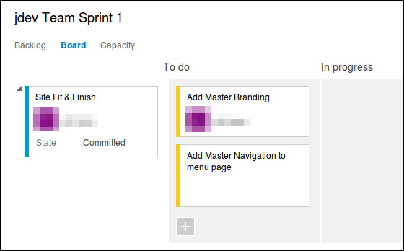

You need to assign the **Add master navigation to menu page** Task to you.

1. Move your mouse and hover over the card and you’ll get a combo-box that opens up.

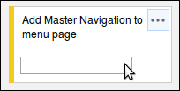

1. Assign the task to yourself.

One more thing you need to do is add an estimate for each work item.

1. Open each task and change the **Remaining Work field** to **1** and then click the **Save and close** button like earlier.

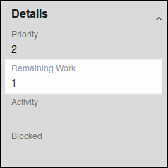

Now you want to show that you’ve started working.

1. Drag and drop the **Add Master Branding** work item to the **In progress** column.

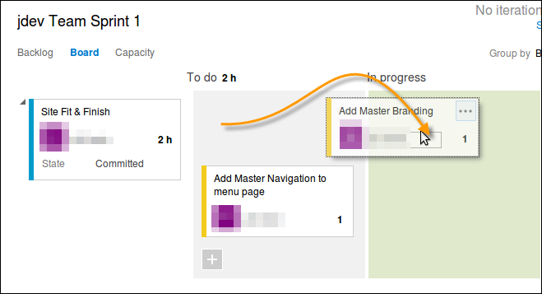

1. In the upper right corner of the Task board, click the **Settings** icon



This opens the Settings dialog where you can make adjustments to many features of the Work Hub including the Task board.

1. For **Task** check the **Show ID** checkbox to show the work item ID on the cards.

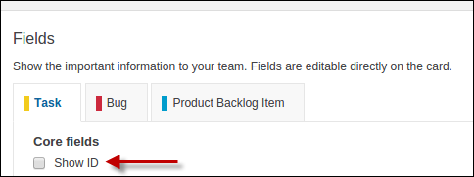

1. Click **Save and Close** when done.

Now you’ll be able to see the Work Item ID easily when you look at the Task board. You’ll use the IDs later when you commit code to your Git repo in the next exercise.

This is a quick introduction to the Agile Planning tools and Work Items. You’ll work with them some more later. If you want to read more about the Agile Planning tools, Sprint Planning, and the Scrum template follow this link: <https://msdn.microsoft.com/en-us/Library/vs/alm/Work/scrum/sprint-planning> .

To give feedback please write to [devopsdemos@microsoft.com](mailto:devopsdemos@microsoft.com)

Copyright © 2016 by Microsoft Corporation. All rights reserved.